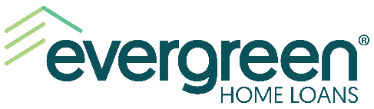

FOR IMMEDIATE RELEASE

EVERGREEN HOME LOANS Named title SPONSOR and underwriter OF 23rd Annual KZOK “ROCK THE HARVEST” Radiothon event BENEFITING NORTHWEST HARVEST

BELLEVUE, Wash. – September 22, 2020 – Evergreen Home Loans™, a full-service direct home loan lender in the Western U.S., announced that it is the exclusive title sponsor and underwriter of the 23rd annual “Rock the Harvest” radiothon event to benefit Northwest Harvest.

Hosted on Seattle-based rock station KZOK, “Rock the Harvest” is a 12-hour radiothon and online auction benefiting Northwest Harvest and its mission to raise funds to feed individuals experiencing food insecurity across Washington State.

Northwest Harvest estimates that between now and the end of 2020, nearly 2.2 million Washingtonians may experience food insecurity, making the need for an event such as this crucial.

“We’re proud to support the mission of Northwest Harvest,” said Don Burton, President, Evergreen Home Loans. “Starting with the Evergreen Cares Foundation, and now in partnership with the KZOK ‘Rock the Harvest’ radiothon, we’re committed to making a difference for those in need throughout all the communities we serve.”

The 23rd annual KZOK “Rock the Harvest” radiothon is set for October 1, starting at 7 a.m. and lasting for 12 hours. Tune in to KZOK to join us in supporting Northwest Harvest’s mission.

For more information about this worthy cause, click here.

# # #

About Evergreen Home Loans
Evergreen Home Loans has offices in six western states: Arizona, California, Idaho, Nevada, Oregon and Washington. The company is also licensed to originate loans in Alaska, Colorado, and Wyoming. For over three decades, Evergreen has served local communities with affordable home loan products while focusing exclusively on home lending. A+ rated by the Better Business Bureau and a proud member of the Washington Mortgage Bankers Association and Mortgage Bankers Association, Evergreen offers a full range of loan products including FHA and VA, Conventional, Jumbo, USDA loans, refinancing and construction financing programs. More information about Evergreen can be found on its website at www.evergreenhomeloans.com. Evergreen Home Loans is a registered trade name of Evergreen Moneysource Mortgage Company® NMLS ID 3182. For individual and company license information visit www.nmlsconsumeraccess.org/

Media Contact: Chris Guizlo or Bailie Pelletier, The Fearey Group for Evergreen Home Loans, evergreen@feareygroup.com or 206-343-1543.

